DivX – Frequently Asked Questions

What is DivX?
Which Philips products are able to playback DivX format?
Do DivX coded discs have the same features as normal DVD movies?
What is a “codec”?
Do Philips products support other codecs, such as Xvid and Microsoft MP43?
Do Philips products support Q-pel and GMC?
Do Philips products support DivX video-on-demand (VOD)?
The audio in my DivX file is out of sync. What can I do?
The audio in my DivX file has a low volume. What can I do?
The DivX movie does not contain audio. What can I do?
How can I get subtitles with the DivX movies?
Customer doesn´t see the subtitles during playback of the movie, what´s wrong?

Commented / modifications by Jib, August 2004 (text in yellow color)

http://perso.wanadoo.fr/ablon/dvp720

What is DivX?
The DivX® codec is an MPEG-4 based video compression technology that can shrink digital video to sizes small enough to be transported over the Internet, while maintaining high visual quality. To view the compressed version of the video, you need a media player designed to play DivX-encoded content.

Which Philips products are able to playback DivX format?
DVD players: DVD737, DVP630, DVP632, DVP720SA, DVP762, DVP721VR.
Home Cinema (HTiB): LX3900SA, LX3950W, LX8300SA, LX8500W.

Do DivX coded discs have the same features as normal DVD movies?
DivX discs do not have: camera angle possibility; subtitle selection during playback (only 1 subtitle file can be selected before playing); more audio languages to select.
Jib : This is not really true with DVP 720 ; you can have several audio languages and subtitles for the same movie

What is a “codec”?
Codec stands for “coder-decoder”. It´s a software package on a PC that can encode a movie to DivX. For playback it can decode a DivX movie.
Currently for DivX, the versions are DivX3.11, DivX4, and DivX5.xx. These different codecs are not intercompatible, i.e. having codec for DivX3.11 doesn´t mean that you can playback a DivX5.xx clip, and vice versa. The Philips products are able to playback: DivX3.11 Low Motion & Fast Motion; DivX4; DivX5.xx (5.01/5.02/5.03/5.04/5.05/5.10/5.11/5.2).

Do Philips products support other codecs, such as Xvid and Microsoft MP43?
Currently, most downloadable movies are a mixture of the following codecs: DivX, Xvid, and Microsoft MP43. For Philips players, only DivX is officially certified. For Xvid and MP43 we do not guarantee total support.
In addition, there are many different encoders to encode the movies into DivX format. Only the official encoder used by DivX –DrDivX- is 100% guaranteed. There are others like Vidomi and Gordian Knot, which in some situations may cause problems during playback.

Do Philips products support Q-pel and GMC?
Not all products. For example, the DVD737 and DVP630/632 do not support these features, but the DVP720SA does support Q-pel and GMC.
(Q-Pel means Quarter Pixel and GMC means Global Motion Compensation. They both belong to advanced features of MPEG4 format, enhancing video playback quality.)

Do Philips products support DivX video-on-demand (VOD)?
The new DivX players for 2004 provide the customers with a DivX VOD registration code. This allows customers to rent and purchase videos using the DivX VOD service. More info can be found on www.divx.com/vod.

The audio in my DivX file is out of sync. What can I do?
Audio sync problems usually indicate that something was not right during the encoding process, rather than any specific problems with your PC´s set-up.

The audio in my DivX file has a low volume. What can I do?
If the DivX file has been converted from a DVD, the low volume is normally associated with the dynamic nature (high highs and low lows) of DVD audio tracks. Some ripping or DivX codec software can normalize the audio.

The DivX movie does not contain audio. What can I do?
It´s possible that the customer has not correctly “muxed in” the audio while creating the disc. Most applications require that you encode the video and audio separately. These two separate streams must be “muxed” (i.e., combined) after they are encoded.

How can I get subtitles with the DivX movies? For DVP 630 / 632 only :
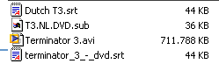
The customer needs to download a separate DivX subtitle file in order to have subtitles in his movie! Once he downloaded a subtitle file he has to place this file in the same folder as the DivX movie. The subtitle file has to have the extension SRT or SUB. It is possible to store more than one subtitle file on the same disc.
See example on the right:
The files ending on .srt and .sub are three different subtitles files.
The file ending on .avi is the actual movie.

Customer doesn´t see the subtitles during playback of the movie, what´s wrong?
Customer has to select the subtitle before playing the movie:
Jib : not for the DVP 720 ; subtitle will be automatically selected, see below

For DVP 630 / 632 only :

1) After inserting the disc, the disc menu will appear:
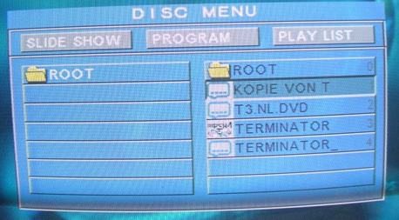
Subtitle
files
Movie File

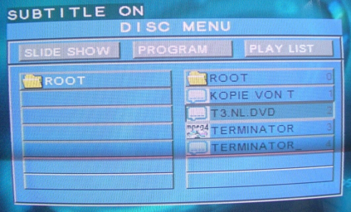
2) Customer has to select the subtitle file and press “subtitle” on the remote control. In the top of the screen it wil say “Subtitle on”:

3) Lastly, customer has to select the movie, and press “ok” or “play” on the remote control. On the screen it will say “Reading Index” and the movie will start playing:
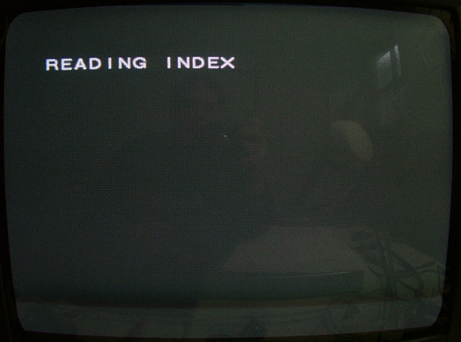

For DVP 720 only : (added by Jib)

You need to name your movie and your subtitle file exactly the same way, for example:
mymovie.avi / mymovie.srt

Place your subtitle file in the same folder as the DivX movie (extension SRT, SMI, SUB or SSA).

It is possible to have more than one subtitle file for the same movie :
mymovie.01.srt
mymovie.02.srt
…
(01 and 02 could be anything else such as “ fra “ or “ eng “)

The subtitle file will be automatically selected when you start playing a DivX file. You can activate, deactivate or switch subtitle files by pressing subtitle key on the remote during playback.

